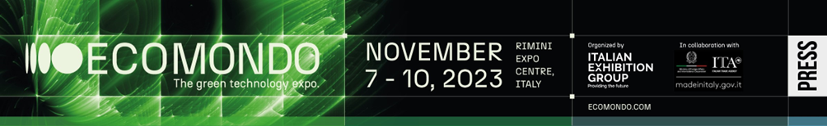

final press release
(English translation)

ECOMONDO 2023, +15% ATTENDANCE: THE ECOLOGICAL TRANSITION IS READY

- The 26th edition (the first without KEY) of Italian Exhibition Group's international circular economy trade show closed today with a major leap forward compared to 2022.
- The largest representation from Spain, Germany, Greece, Serbia, Egypt and Tunisia
- Minister Pichetto Fratin: «Ecomondo, from pioneer model to national flagship»
- IEG launches the green innovators award named after Lorenzo Cagnoni

ecomondo.com

Rimini, 10th November 2023 – The market is asking for ecological transition, Ecomondo proves that it is ready to go. Italian Exhibition Group's international circular economy exhibition closed its 26th edition with 15% more attendance than in 2022 (a figure that is even more significant since, last year, it took place at the same time as KEY Energy Transition Expo, which has now earned its own calendar slot).
150,000 square metres for more than 1,500 exhibiting brands, up 10% compared to last year, for four extremely intense days of business and networking. Digital participation through the b2b GreentechInsights platform was also greater, with 600,000 exhibitor profile viewings. Excellent media coverage: + 10% more that the over 500 million contacts in 2022 for one of the highest impacts ever on Italian and international public opinion.

DECARBONIZING IS WORTH IT
From regenerative bio-economy to blue economy, from waste as a resource to soil restoration, from bioenergy to environmental monitoring: the largest edition in 26 years gave a clear signal: circularity technologies are ready to regenerate ecosystems and are profitable when combined with decarbonisation-oriented policies. Also on show were the latest environmentally friendly vehicles in the biennial SAL.VE exhibition organised with ANFIA. Besides the content on display in the Rimini Expo Centre halls, green is also confirmed as profitable for the economy in the report “The economy of tomorrow: a decarbonised, circular and regenerative green economy” presented at the opening of the States General of the Green Economy 2023. Benefits of 689 billion euros over a ten-year period are estimated against cumulative costs of 136.7 billion from the “Fit for 55” European decarbonisation regulatory package alone.

ECOMONDO, INTERNATIONAL PLATFORM
Ecomondo’s foreign visitors come from an increasing number of countries, mainly from the Euro-Mediterranean area, with Spain, Germany, Greece, Serbia, Egypt and Tunisia in the lead, followed by Sub-Saharan Africa. Over 630 international foreign operators were hosted thanks to the collaboration of ITA – Italian Trade Agency, the Ministry of Foreign Affairs and International Cooperation, IEG's global network of regional advisors and also the Emilia-Romagna Region, particularly for the Blue Economy sector, coming from North and Sub-Saharan Africa, the Balkan area, Latin America, North America, India and the Middle East, generating and overall total of 2,700 business matchings.

ECOMONDO, AN INNOVATOR HUB
Start-ups and Scale-ups, essential ingredients at Ecomondo. This year, an award named after Lorenzo Cagnoni was launched for consolidated and emerging innovators in the ecosystem of Italian green companies. The podium was taken by Eco Reciclyng from Viterbo, HBI from Treviso, and the global brand AMP Robotics while the three winning start-ups were 3Bee from Milan, Oxoco from Bari and Mixcycling from Vicenza. The companies and public administrations most committed to eco-innovation were honoured with the Sustainable Development Award promoted by the Sustainable Development Foundation and Ecomondo.

ENVIRONMENT MINISTER PICHETTO FRATIN: ECOMONDO IS A NATIONAL FLAGSHIP
The inaugural day was attended by Minister for the Environment and Energy Security, Gilberto Pichetto Fratin, who toured the exhibition area with IEG Chairman Maurizio Ermeti, CEO Corrado Peraboni and Global Exhibition Director, Alessandra Astrolfi. In his opinion Ecomondo has gone «from a pioneering model to a national flagship». Francesco Corvaro, the Italian Government’s Special Envoy for Climate Change at COP28; the President of the Emilia-Romagna Region, Stefano Bonaccini, and Rimini Councillor for Ecological Transition, Anna Montini, were also in attendance. During the four-day event, Ecomondo's guests included Vice Minister for the Environment and Energy Security, Vannia Gava, the Undersecretary to the Ministry for the Environment and Energy Security, Claudio Barbaro, the Undersecretary to the Presidency of the Council, Alessandro Morelli, and the Undersecretary to the Interior, Emanuele Prisco, members of the Ecoreati parliamentary Commission, the President of the Campania Region, Vincenzo De Luca, and Michele Emiliano from the Apulia Region. The supply chain consortia and business associations, the event's historical partners, starting with CONAI, Utilitalia, Assoambiente and Confindustria, together with the European Commission, OECD, FAO, UfM, EEA and ISWA, coordinated by the event’s technical-scientific committee headed by Professor Fabio Fava from Bologna University, make Ecomondo the community catalyst of reference in the Euro-Mediterranean area with a calendar of over 240 events.

Ecomondo will be back in Rimini from 5th to 8th November 2024

ABOUT ECOMONDO 2023
Event: International trade show; Organizer: Italian Exhibition Group S.p.A.; Frequency: annual; Edition: 26th; Dates: 7-10 November; mail: ecomondo@iegexpo.it; Website: www.ecomondo.com; Facebook: www.facebook.com/EcomondoRimini; Twitter: http://twitter.com/Ecomondo; LinkedIn: https://www.linkedin.com/company/ecomondo-the-green-technologies-expo/

PRESS CONTACT IEG
head of media relation & corporate communication: Elisabetta Vitali; press office manager: Marco Forcellini; international press office coordinator: Silvia Giorgi; media@iegexpo.it

MEDIA AGENCY: MY PR Lab
Filippo Nani, filippo.nani@myprlab.it; Enrico Bellinelli, enrico.bellinelli@myprlab.it; mob. +39 392 7480967; Francesca Magnanini, francesca.magnanini@myprlab.it; mob. +39 338 6910347; Giulia Lucchini, giulia.lucchini@myprlab.it, mob. +39 348 7853679

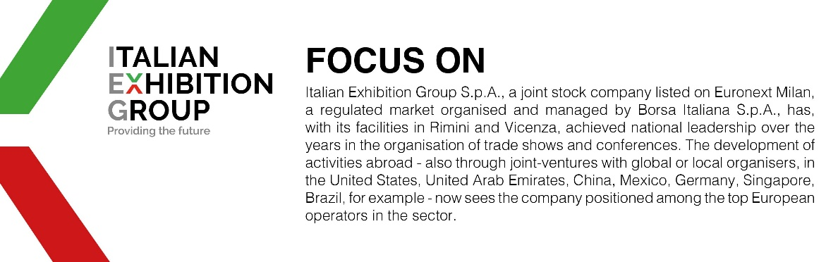

This press release contains forecast elements and estimates that reflect the management’s current opinions (“forward-looking statements”), particularly regarding future management performance, realization of investments, cash flow trends and the evolution of the financial structure. For their very nature, forward-looking statements have a component of risk and uncertainty, as they depend on the occurrence of future events. The effective results may differ (even significantly) from those announced, due to numerous factors, including, only by way of example: food service market and tourist flow trends in Italy, gold and jewellery market trends, green economy market trends; the evolution of raw material prices; general macroeconomic conditions; geopolitical factors and evolutions in the legislative framework. Moreover, the information contained in this release does not claim to be complete, and has not been verified by independent third parties. Forecasts, estimates and objectives contained herein are based on the information available to the Company as at the date of this release.

